CS5600: Programming Assignment 2 (50 points)
In this assignment, you will learn and implement CRUD (Create, Read, Update, Delete). These are the basic APIs to perform at most functions on web applications. You will develop the back end and frontend web frameworks such as React, Angular, Streamlit, Flask, …, etc. The following figure is a GRAND stack framework. It is a core of framework for this assignment.
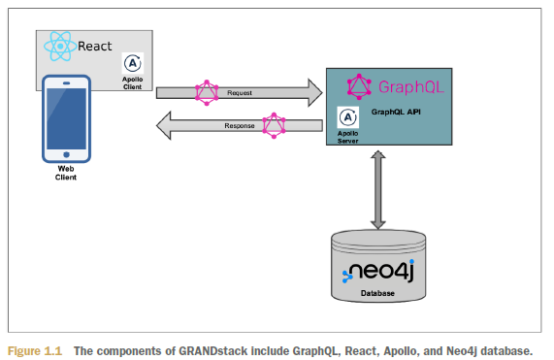
Source: https://www.manning.com/books/fullstack-graphql-applications
You can use any programming languages such as Python, Java, NodeJS, C#, …, etc. The backend web framework must connect to Neo4j on cloud database-Neo4j Aura (https://console.neo4j.io).
You can use the neo4jGraphQL library for implement CRUD operations and must check the video on Brightspace for GraphQL APIs connect to Neo4j database.

You can also generate Neo4j Database on local using Neo4j Desktop. The instructor will guide you how to import .csv files and generate the database on local machine or Neo4j Aura

The CSV file (IMDB-Movie-Data.csv-Movies on IMDB.com) is provided in this assignment with the column names including:
Ids
Title
Genre
Description
Director
Actors
Year
Runtime (Minutes)
Rating
Votes
Revenue (Millions)

The instructor will guide you how to generate Neo4j Database on cloud database using Neo4j Aura(https://console.neo4j.io). You will import the sample csv file to create graph database on Neo4j DBMS.
This is a database model for the assignment:

Actor
[ :ACTED_IN ]
Movie

[ :DIRECTED ]
Director
[ :IN ]

Genre
Nodes:
Movie [ ids, title, description, year, runtime, rating, votes, revenue ]
Actor [ name ]
Director [ name ]
Genre [ type ]
Relationships:
ACTED_IN
DIRECTED
IN

Users must connect to LLMs (Large Language Models)-only open-source models such as Ollama, LM studio,…, etc. no use any proprietary LLMs such as OpenAI,…, etc. The users enter the natural language for the CRUD operations. So LLMs must translate into the Neo4j GraphQL APIs query commands, execute the commands and display the response message on the webpage. The are some videos on Brightspace talk about LLMs and usage. You can check the videos for introduction to LLMs. You should use the AI framework orchestras such as Pydantic, Llama index, LangChan, LangGraph, …, etc. The instructor will guide you on how to use it in the assignment.
The following figure is a sample of the interface using streamlit tool:
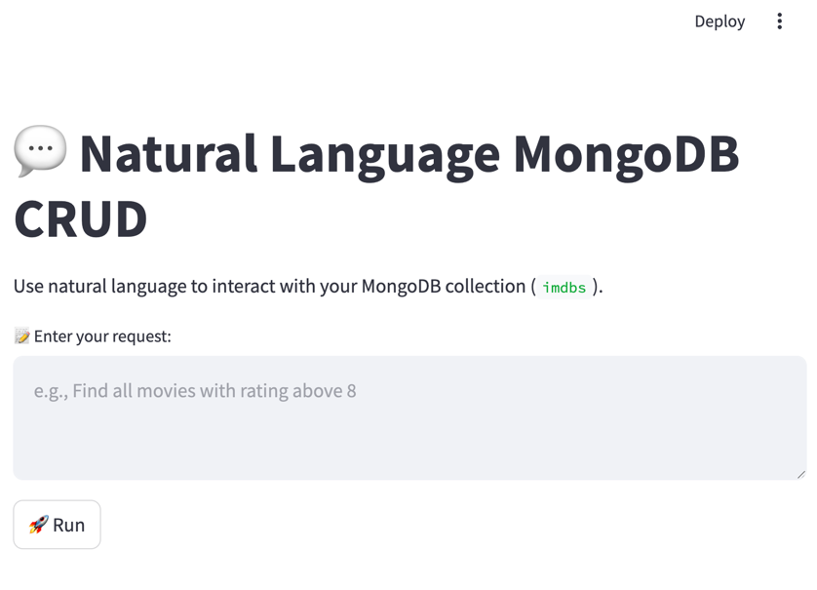

You should create the application using GraphQL APIs for 4 main functions:
- Create function
- Update function
- Delete function
- Retrieve function

Submission:
Turn in your codes and data files in folder name “PROG_ASSIGN2_XXXXX_YYYYYY” where XXXXX is course number (CRN) and YYYYYY is 700# student id and zip the folder before submitting your assignment.

Notes: (Please read it before starting the assignment)
If you want to use other platforms beyond Apollo Server. You must contact me beforehand and let me know how to use the platform. You can use internet cloud application platforms such as Heroku (https://www.heroku.com) if you prefer. However, in your assignment submission, you must provide me with the links for executing the application and source code. You are very welcome to use any LLMs chatbot such as ChatGPT, Gemini, Grok, Claude, …, etc. with any LLMs tools to help for coding such as Copilot, Cursor AI, …, etc. In the zip file submit folder you have to include the document to instruct me how to execute the application what is LLMs you use for the assignment. Please contact me if you have any questions or concerns.

